REPORT
“SSIP 2.0 Awareness Seminar”
Electrical Engineering Department, L. D. College of Engineering, Ahmedabad - Gujarat had organized a seminar on " SSIP 2.0 Awareness Seminar " under egis of SSIP Cell of the Department on 04 May,2023 at 03:30 PM in room 211.
The Speaker was Prof. Mihir Vasavada and Prof. Vihang Dholakiya, Assistant professor from electrical engineering department, Ahmedabad. The seminar was co-ordinated by Prof. Mihir Vasavada with students.
A brief introduction about of SSIP cell, IPR cell and about the PoC projects funded under SSIP and about the students sensitized through the SSIP awareness Program to the speaker and to the participants. Around 99 students participated in this seminar. Speakers have conducted the session with many examples of innovators and young minds popping with great ideas with the positivity.
The challenges, failure and success in the path of the innovator’s life are difficult full of hardships but one should not give up or suppress the budding ideas and let them bloom and flourish with courage and motivation.
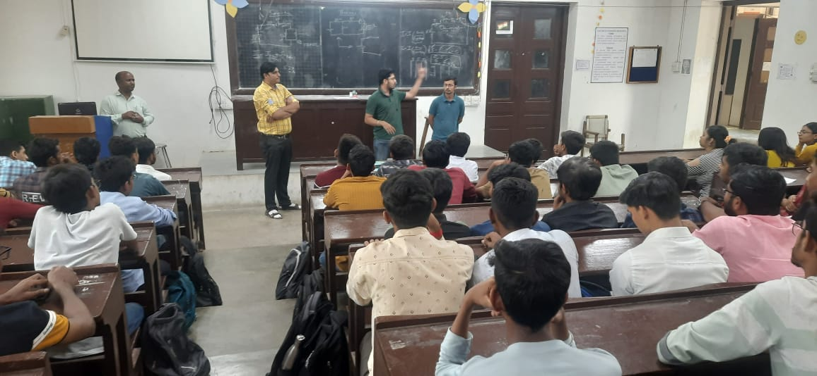

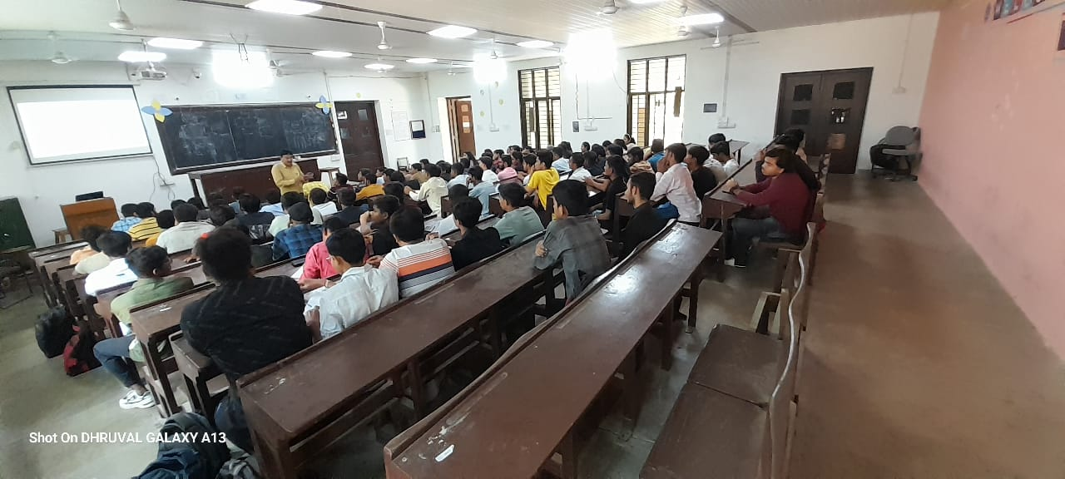

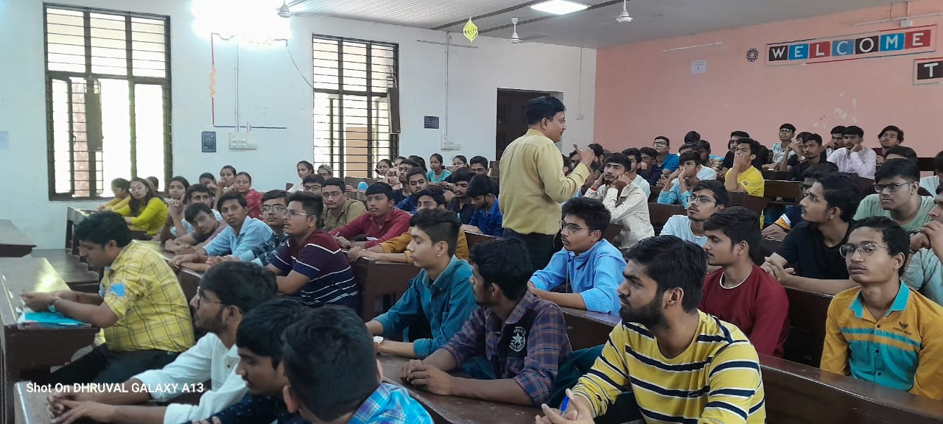

After the inspiring talk, an open conversation was followed on how to get fund for carrying a start- up to motivate and provoke students not to quench their dreams and always remain hungry for more dreams followed at the by the Vote of thanks was offered by Prof. Mihir Vasavada.

